Implementation of system call ftruncate() on nix os

To implement and test the ftruncate() system call inside the NixOS operating system running in a virtual environment. This system call will be used to resize an existing file to a shorter size, verifying POSIX compliance within NixOS.

### 🛠️ **Step-by-Step Implementation on Nix**

#### 🧱 **Step 1: Open Terminal**

* Press Super (Windows key) → type Terminal → Press Enter. 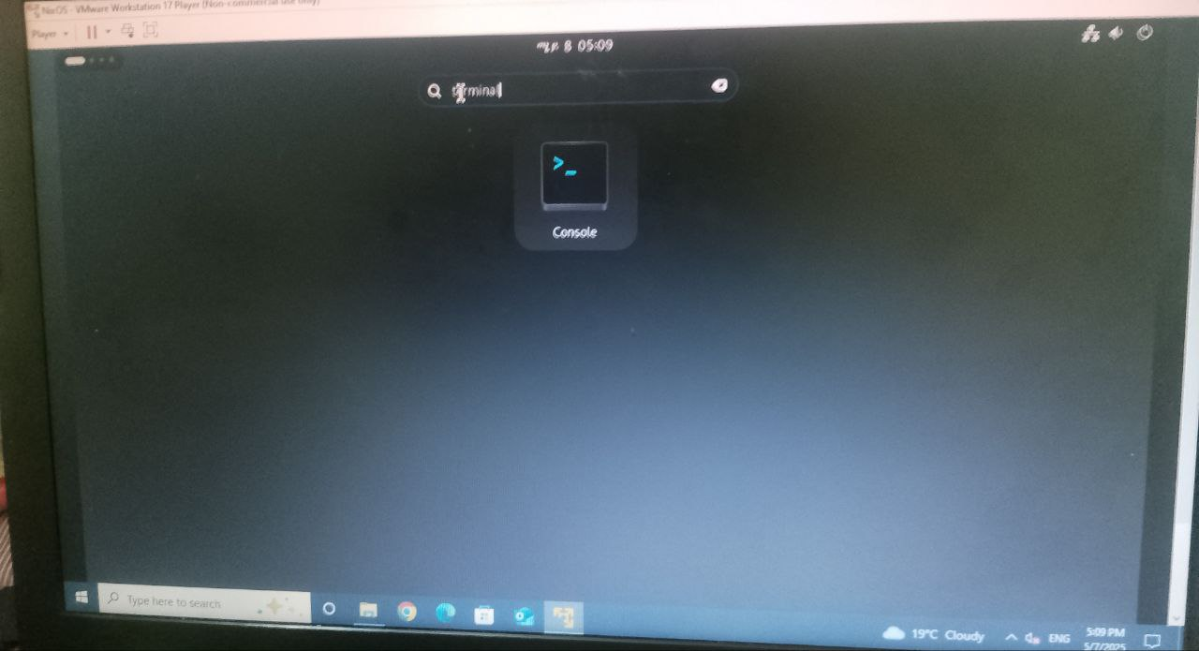

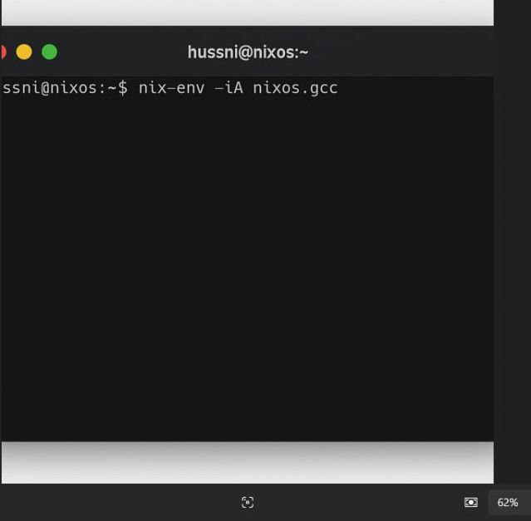

#### 🧾 **Step 2: Install GCC Compiler (if not installed)**

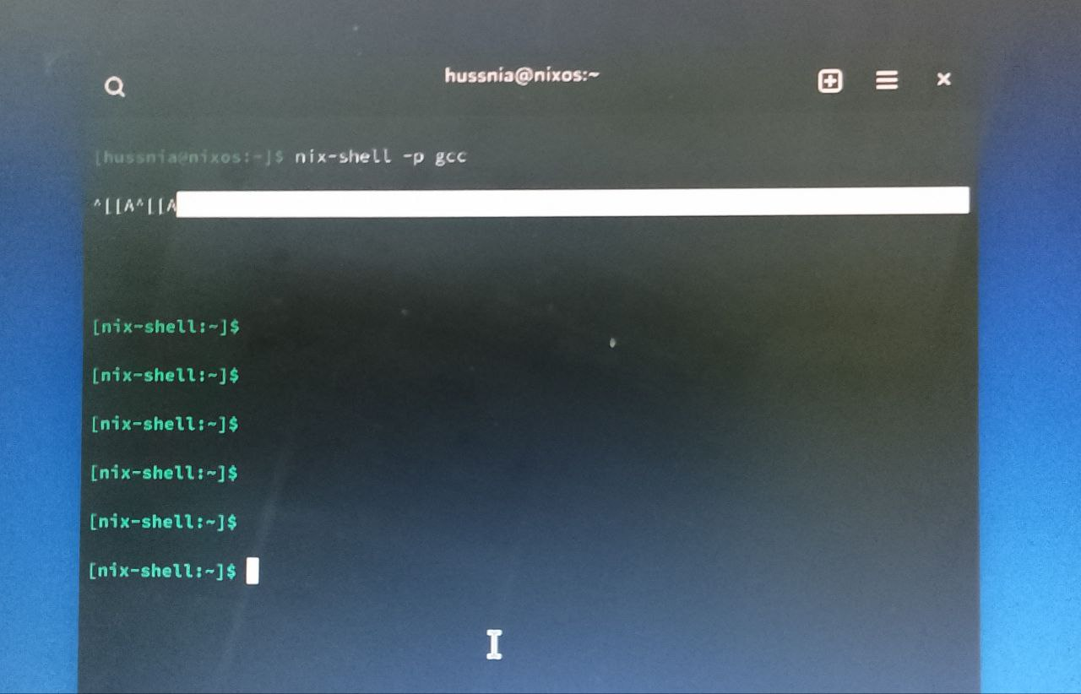

|  |
| --- |
| nix-env -iA nixos.gcc |

This command installs the GCC compiler which is necessary for compiling C programs in NixOS.

#### 📄 **Step 3: Write the C Program**

1. In the terminal, open a text editor (e.g., nano):

|  |
| --- |
| nano ftruncate_example.c |

1. Paste the following code:

c

|  |
| --- |
| #include <stdio.h>  #include <stdlib.h>  #include <fcntl.h>  #include <unistd.h>  int main() {  const char *filename = "example.txt";  // Open file with read/write access, create it if it doesn't exist  int fd = open(filename, O_RDWR | O_CREAT, 0644);  if (fd < 0) {  perror("open");  return 1;  }  // Write initial data  write(fd, "Hello from OSSP project using ftruncate!\n", 41);  // Truncate to 10 bytes  if (ftruncate(fd, 10) == -1) {  perror("ftruncate");  close(fd);  return 1;  }  printf("File has been truncated successfully.\n");  close(fd);  return 0;  } |
|  |

### 

### **Explanation for OSSP Report**

In this implementation, the ftruncate() system call was used to shorten a file to 10 bytes. This was done inside the NixOS virtual environment, demonstrating compliance with POSIX standards. We used the open(), write(), ftruncate(), and close() system calls defined in <fcntl.h> and <unistd.h>. The successful output and reduced file size confirm the functionality of ftruncate() in NixOS.

### 📌 Optional: Automation with Bash Script

Create a script to run all the steps automatically:

1. Create script file:

bash

CopyEdit

nano run_ftruncate.sh

1. Paste:

bash

CopyEdit

|  |
| --- |
| #!/bin/bash gcc ftruncate_example.c -o ftruncate_example  ./ftruncate_example  ls -l example.txt  cat example.txt |

|  |
| --- |
| chmod +x run_ftruncate.sh  ./run_ftruncate.sh |

1. Save and exit, then give permission:

